Forest Challenge!

The orienteering board game for 2-6 players from
North Gloucestershire Orienteering Club

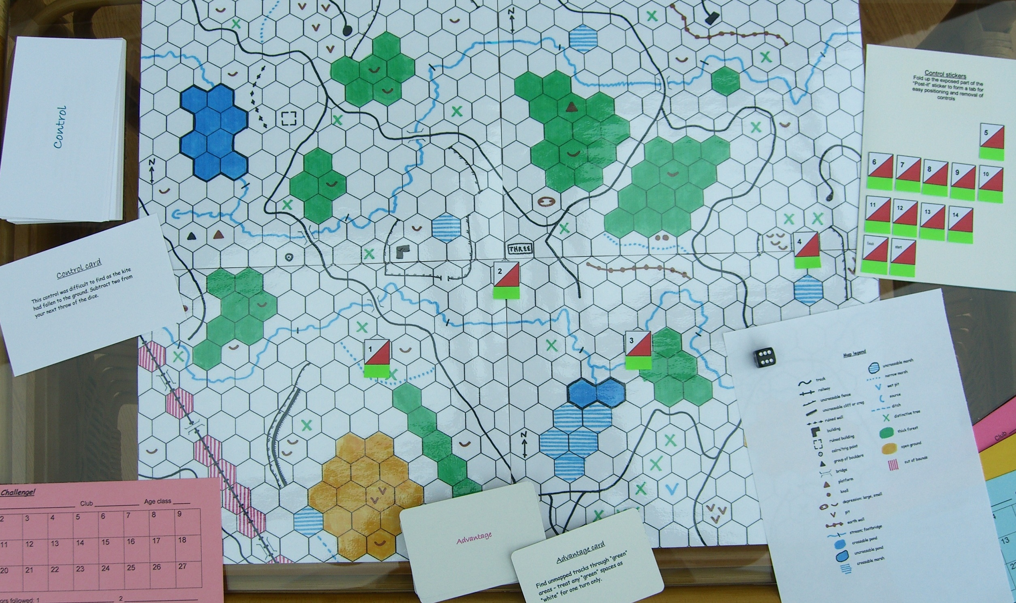
- The game includes everything you need – laminated map, kites, punch cards, “Control” cards, “Advantage” cards, instructions, dice, tokens etc.;
- Design a different course each time you play by using the moveable control stickers;
- The map sections can be fitted together in different combinations for more variety;
- Choose score or line orienteering;
- Add even more variety by drawing your favourite terrain on the blank map grids supplied.

General idea of the game. Each player takes it in turn to throw the dice and move his token between controls, choosing his own route as in real orienteering. On reaching a control a player takes a Control card and follows its instructions. During the game players can use their Advantage cards in conjunction with their dice throw to help them get ahead of, or catch up, other players. The winner is the first player to reach the finish line. The use of moveable control stickers means that you can run a different course every game!

Cost of the game is £11-00 (including postage) from Alan Brown, 10 Brizen Lane, Cheltenham, GL53 0NG. Cheques payable to NGOC (or pay by PayPal or bank transfer). Email Alan Brown for further information at alan@brizen.co.uk

